Handling the Information Backlog for Data Warehouse Development

Naveen Prakash¹, Deepika Prakash²

¹Deptt. Of Computer Science and Engg., IIITD, New Delhi 110020, India
praknav@hotmail.com
² Deptt of Computer Engineering, NIIT University, Neemrana 301705, India
dpka.prakash@gmail.com

Abstract: In both, bus of data marts and agile data warehouse development, it is required to select the next product part to be developed. Whereas this issue is not addressed in the former, agile development approaches leave selection from a backlog to the product owner. We provide an approach to backlog selection that is rooted in the decision-making process. Our task is to first select a decision from a backlog of decisions and then select from the backlog of information relevant to it. Three yardsticks are considered for decision selection, business importance, decision structure and picking complete decisions in preference to partial decisions. The backlog of information for a selected decision may be for the Intelligence or Choice phases of the decision-making process.

Keywords: iterative data warehouse development, agile data warehouse development, decision backlog, semantic priority, complete decisions, syntactic priority

- Introduction

Since data warehouse projects take long to deliver and are expensive [1], there is considerable pressure from stakeholders to show progress in the development task. This pressure led to the rejection, in practice, of the monolithic development approach of [2]. Reduced lead times is at the core of the “bus” approach of [3]. While promoting iterative and incremental development, this approach has two chief difficulties, (a) there is no guidance on which data mart is to be developed next, and (b) the lead time to delivery is still high. This is because Subject Oriented Requirements Engineering, SORE, [4, 5, 6, 7, 8, 9] develops full requirements specifications for a subject.
Agile development has been adopted in DW development as well. Hughes [10] uses the notion of user stories of Scrum but did not address the issue of selection from a backlog. The agile approach in BEAM* [11] uses the concept of importance to enable selection. However, selection is an unguided, experience based process. In [12], user stories of Scrum were adapted for agile data warehousing. The approach organizes data warehousing in three levels, application, decision, and information. Some guidelines for selecting from the backlog at the application level are provided in [12]. However, for the other two levels, issues in selection were identified but and the selection process itself was not elaborated. We propose to develop such a process in our paper here.
Data warehouses can be built to support complete decisions or, if decisions are complex, then data warehouses for supporting partial decisions can be built. Our partitioning approach is to identify backlog partitions of “complete” decisions and provide support for these. Completeness is defined at the end of section 3. Data warehouse support for complete decisions is taken up earlier than for others.
We assume that selection from the backlog of decisions can be done on a syntactic or semantic basis. The former tells us the number of decisions that must be supported for a given decision to be supported. As far as we are aware, there is no literature about the lead time required to support decisions. Therefore, we make the simplifying assumption that all decisions take equal time. Our heuristic is that if the number of decision to be supported is larger for decision, A than for decision, B. then A shall require more time for delivery than B. Thus, a low value of syntactic priority promotes early delivery. Semantic priority is specified by the stakeholders of the data warehouse to-be. A number of methods for specifying it are available [13, 14, 15 16, 17, 18]. We adopt the strategy of AHP where relative priorities are assigned to candidates such that the sum of the priorities adds up to unity. Evidently, the larger the value of semantic priority, the more important it is from the business perspective.
It is possible that there is a conflict between syntactic and semantic priorities. We have three possible conflict resolution strategies, (a) Give preference to syntactic priority over semantic priority, (b) Semantic priority overrides syntactic priority, and (c) Perform selection as an interaction with the stakeholder and do not commit to any overriding. We superimpose the notion of completeness on these strategies. If the nature of the backlog is such that its decisions provide complete support in the decision making task, then we adopt the first strategy. If the backlog has decisions that provide partial support then we adopt the second strategy: important partial support is provided while we wait for full support. We follow the third option only when there is a conflict that requires human intervention.
Once a decision is selected, the next issue is to identify the information relevant to it. Following the decision model of Simon [19], we formulate procedures for supporting the Intelligence or Choice phases of the decision-making process.
The layout of the paper is as follows. In section 2, we review the basic concepts underlying decision-making. In section 3, we consider the different types of decision backlogs and some basic strategies to handle them. Sections 4 to 7 contain procedures for selection of decisions from the different kinds of backlogs. In section 8, we present procedures for selecting from the information backlog.
- The Decision Making Process
The decision making process of Simon [19] consists of three main activities, Intelligence, Design and Choice. In the phase of intelligence, the decision maker analyses the current situation with a view to discovering a problem requiring decision making. The decision-making problem is formulated during the design stage. During the Choice phase, the most appropriate alternative is selected.
A decision is a commitment to an action, course of action, or strategy. We will refer to these collectively as action unless required otherwise. This commitment implies that the action must be taken to completion. There are two kinds of decisions, simple decisions that cannot be decomposed and compound decisions that consist of other simpler decisions. It is also possible for decisions to be dependent on one another.
A decision problem is a design artifact built during the design phase. Two widely prevalent representation systems for the design problem are decision trees and influence diagrams. Whereas the former provides detailed decision logic and can be visualized as a flow chart, the influence diagram presents a global picture of the decision problem. This larger view point is interesting for us since it provides to us the concepts for selection from a backlog.
An influence diagram [20] is a directed acyclic graph with three kinds of nodes and two kinds of edges. Its nodes are as follows:
- Decision nodes represented as rectangles. These nodes represent the choices that are available. The probability of selecting a choice is the same as that of selecting any other one. Further, at least one of the choices shall be selected.
- Uncertainty nodes represented as ovals. Ovals represent situations that are beyond the control of the decision maker. The individual probability of any situation occurring can be only estimated within a certain range of possibilities. The term, uncertainty, conveys that the situation at the time the decision is taken and the situation when the effect of the decision is felt may be different. For example, product price after purchase may change by the time the product is delivered.
- Outcome nodes are rounded rectangles that represent decision outcome.
The influence diagram has two kinds of edges, namely
- Functional edges represented as solid arrows say that the node at the source of the arrow is relevant for assessing the value of the node at the arrow head.
- Information edges represented as dashed arrow indicate that knowledge of the predecessor node is available when the successor node is being considered.

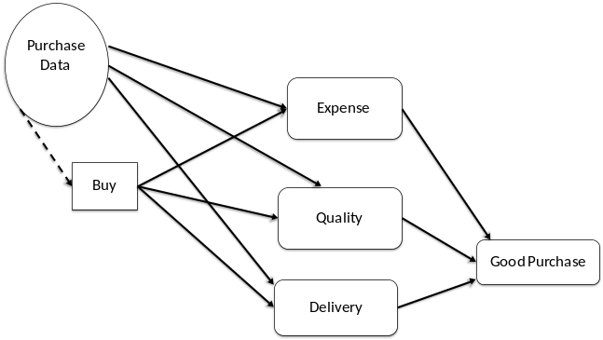
Fig. 1: The Basic Buy Decision

Let us exemplify the foregoing with the decision, Buy stock. Our decision maker must decide which material is to be bought from which supplier. This is the Buy decision node of Fig. 1. The uncertainty, Purchase Data, in the figure includes, expected demand, current price, history of price movement, expected material delivery delay etc. The dashed arrow, i.e. the information edge says that Purchase Data for all products to be purchased is needed for the decision. The outcomes are Expense, Quality, and Delivery, all contributing to the main outcome, Good purchase. The objectives used to evaluate these are Minimize Cost, Maximize quality and Maximize punctual delivery.
- Defining the Backlog of Decisions
One way of defining the backlog is to treat it as being the universe of all decisions of interest. If this universe is large, then assigning semantic priorities may present difficulties. Further, if the universe changes rapidly, then handling changing priorities may be a challenge. Therefore, we adopt the divide and conquer approach and create four partitions of the universal backlog.
The decision backlog is the aggregate of four kinds of backlogs, namely, Free, Specialized, Composite, and Mixed backlogs. The first of these contains complete decisions that are stand alone and are the best candidates for early data warehouse support. The second develops specialization hierarchies for complete decisions. Each node in the hierarchy is a special case of the root decision and is complete in its own right. However, the root of the hierarchy is only completely supported after all specialized decisions are supported. Given that completeness permeates the hierarchy, selection from the specialized hierarchy is given second preference. Third preference is given to selecting from the backlog of composite decisions because a composite decision is only supported after all its component decisions have been supported. The component decisions have only partial value and are interesting as part of the composite decision. Finally, the backlog of mixed decisions is the last one from which selection is made. For such decisions, first selection is made from its specialized decisions, then dependent and finally composite. This delivers special cases of high complexity early.
These four backlogs are formed as follows:
- A decision that is atomic (cannot be decomposed into simpler ones), does not give rise to a specialization hierarchy, and is not dependent on any other decision, is a standalone decision, an individual decision. We refer to such decisions as “free” decisions and the backlog of such decisions is called a free_backlog.
- The specialized_backlog consists of a set of atomic decisions. Each decision in this set gives rise to a specialization hierarchy, and is not dependent on any other decision.
- The composite_backlog is a set of composite decisions that do not give rise to a specialization hierarchy, and are not dependent on any other decision.
- Finally, the mixed_backlog is a set of decisions in which a decision is composite OR gives rise to a specialization hierarchy OR is dependent on any other decision.

Now, we can define a complete decision. A decision is complete if it is
- Not dependent on another decision or if dependent on decision D, then D has already been selected earlier, and
- Cannot be decomposed into others or if all its components have been selected earlier, and
- Cannot be specialized into others or if all the specialized decisions have been selected earlier.
- Selecting from Free_Backlog
The stakeholder assigns semantic priority, sem to the decisions comprising the backlog. Since all decisions are atomic and are not roots of a specialization hierarchy they have the same structural priority. ND is the one with the highest semantic priority and post selection, it is removed from Free_backlog. Consider Free_backlog = {D₀, D₁, D₂, D₅} whose dependency graph in Fig. 2.

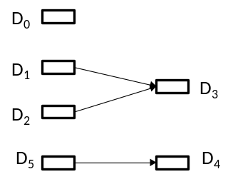

Fig. 2: Dependency between Decisions

Let the semantic priorities be Sem(D₀) = 0.4, Sem(D₁) =0.3, Sem(D₂) = 0.2 and Sem(D₅) = 0.1. The selected ND is D₀. It is removed from Free_backlog. The newly computed Free_backlog is {D₁, D₂, D₅}. The selected ND is D₁ and it is removed from Free_backlog giving us the free_backlog = {D₂, D₅}. The next selection is D₂ and its removal makes D₃ eligible for inclusion in Free_backlog that is now {D₃, D₅}. Since it has not been prioritized with respect to D₅, relative priorities are now assigned and the procedure continues.
- Selecting from Specialized_Backlog
Consider a collection of decisions each of which gives rise to a specialization hierarchy. First we need to select the decision from the collection and then select from the hierarchy of the selected decision. We determine the specialized syntactic priority, Ssyn of each decision in the hierarchy as the number of its specialized decisions. We adopt the heuristic that a decision with a higher value of Ssyn will take more lead time to support than one with a lower value. This is because the number of decisions to be supported is larger in case of the former. The method of selection is as follows.
- The decisions in the Specialized_backlog are assigned semantic priorities, Sem by assigning values that add up to unity. Present to the stakeholder, the specialized_backlog in increasing order of syntactic priority. Let the stakeholder select decision D. Mark the decision as selected.
For the hierarchy rooted in D Repeat
- Move to next lower level of the hierarchy. If no such level then go to 4.
- Select the decision with the least syntactic priority, Syn. If several decisions have this value, then determine semantic priority of the decisions and
  - The decision with the highest semantic value is the selected decision of the level.
  - If more than one decision has the least value of Sem then selection is made through stakeholder interaction.
Until a leaf node is marked
- The marked leaf node is the selection from the backlog and is removed from the hierarchy.
- If there are marked nodes in the hierarchy then move to the next higher level and repeat from step 2

Table I: Presenting the backlog
Decision name | Syntactic Priority, Ssyn | Semantic Priority, Sem
A | 10 | 0.3
V | 15 | 0.2
Z | 17 | 0.5

To illustrate, consider a Specialized_backlog = {Z, V, A} each member of which is the root of a specialization hierarchy. The syntactic and semantic priorities are as shown in Table I. The rows are ordered on the syntactic priority.

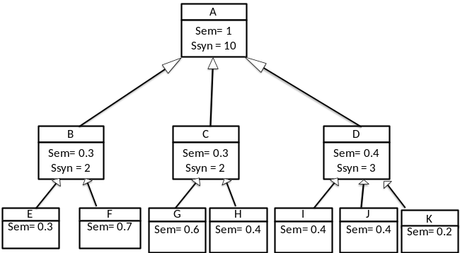
Fig. 3: Selecting from a Specialization Hierarchy

Let the selected ND be A. It is marked as selected (step 1). For the specialization hierarchy of A in Fig. 3, the next level is the set {B, C, D} (step 2). By step 3, Band C are potential candidates and using (ii), let the stakeholder select B which is marked. At the next level, we now have the backlog of {E, F}. These are leaves of the hierarchy and so both have Ssyn = 0. Their Sem values determine that F will be marked and by step (4), it is removed from the hierarchy after declaring it to be the selected decision from the backlog. Following step (5), we position ourselves at B again, and following step (2) E is marked, selected for the next iteration/sprint, and then removed. Now following step 5, we position ourselves at B again. This procedure continues till A is selected. At this stage, attention shifts to selecting from Table I again.
- Selecting from Composite_backlog
A component decision of a composition hierarchy is part of a larger decision. When support is provided to such a decision, then only a part of the entire decision, and not a full case of the decision, is supported. Therefore, it makes better sense to select those component decisions that provide higher semantic benefit than those that can be delivered early.

Table II: Presenting the backlog
Decision name | Syntactic Priority Csyn | Semantic Priority (Sem)
A | 10 | 0.5
V | 15 | 0.2
Z | 17 | 0.3

As before, we present in Table II the relative semantic priorities. The Csync attribute contains a count of the number of component decisions of a decision. Now, the method of selection of the decision to be taken up next is as follows:

- Determine the decision with the highest value of Sem.
While level is not the leaf level do
- Move to next lower level of the composition hierarchy.
- Select the decision with the highest value of Sem. If several such decisions exist then determine their Csyn and
  - The decision with the least value of Csyn is selected.
  - If more than one decision has the least value of Csyn then selection is made through stakeholder interaction.
End
- The leaf node is selected and then removed from the hierarchy.
- Move to the next higher level, if it exists, and repeat from step 2

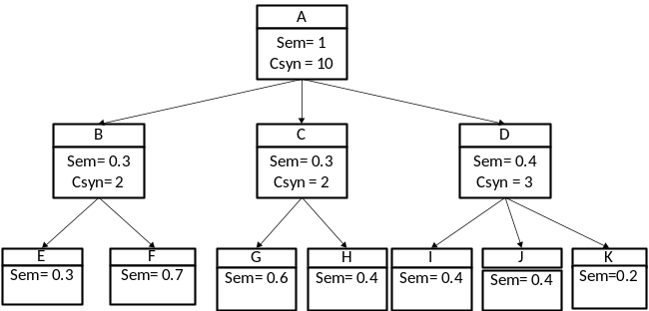
Fig. 4: A Composition Hierarchy
Applying step 1 to Table II, we get A. Applying the rest of the procedure to the composition hierarchy of Fig. 4, we obtain the order I, J, K, D, F, E, B, G, H, C, A.
- Selecting from Mixed_Backlog
Selection from the mixed backlog is done in the order as follows:
- For decisions that have csync=0 and ssync≠0, follow the procedure of section V.
- For decisions having cync≠0 and ssync=0 follow section VI.
- For decisions with csyn≠0 and ssync≠0, first follow section V and then section VI.
For reasons of space, we do not illustrate selection from mixed_backlog here.
- The Information Backlog
Having selected the decision, we now need to consider the information that must be stored in a data warehouse. The entire information backlog consists of the contribution made by Uncertainty and Outcome of the Influence Diagram, as well as that made by the action committed to by the decision. An outcome is evaluated by an objective function of the form y=F(x). Evidently, y and x respectively contribute to the information backlog. On the other hand, the contribution of an action is the record that it leaves behind. If the information backlog obtained is too large then we need to reduce it. At a global level, we do this based on the stage of the decision-making process, Intelligence or Choice, supported by the data warehouse. For the former, information generated by the actions is relevant since a collection of past actions tells us the current situation. For the latter, we need the contributions of Uncertainty and Outcome parts. This is because choice is enabled by the functional link between these.
For the Intelligence phase the data warehouse should contain the current situation of the enterprise. Relevant actions are those that create, read, update, or delete information. Let our decision be a commitment to action, ACT and let ACT leave behind a record of data, R(A₁, A₂, ... , A_{n}). Now, R may be accessed by actions other than ACT, say, ACT₁, ACT₂, ..., ACT_{p}. The record of all ACT_{i} is of interest as well. Yet again, actions that access the new attributes are determined and the process continues till no new actions or attributes are found. The backlog is as follows:
- The record R(A₁, A₂, ... , A_{n})
- All derived attributes DA₁, DA₂, ....., DA_{m} and all base attributes BA₁, BA₂, ....., BA_{k} of attributes of R
REPEAT
- The record of all actions ACT₁, ACT₂, ..., ACT_{p} that access a base or derived attribute.
- Attributes that are derived from ACT₁, ACT₂, ..., ACT_{p}
UNTIL no new Action or new base/derived attributes

To illustrate consider the decision, Buy, once again. Its action, Order associated leaves the record Ordered_product(Order#, Supplier#, Product#, Quantity, Unit price). Now, Total_on_order is derived from quantity because Total_on_order = Total_on_order + Quantity. Similarly, Total_committed_amount = Total_committed_amount + Quantity x Unit price. This gives us the information backlog (a) Ordered_product(Supplier#, Product#, Quantity, Unit price) and (b) Total_on_order and Total_committed_amount.
Now, consider the first iteration for action, Cancel Order that reduces Total_on_order by Quantity_cancelled and also reduces Total_committed_amount by the amount of order cancelled. Its record is Cancelled_product(Cancellation#, Order#, Supplier#, Product#, Quantity_cancelled). At the end of this iteration, information backlog would be
- Ordered_product(Suplier#, Product#, Quantity, Unit price)
- Total_on_order and Total_committed_amount
- Cancelled_product(Cancellation#, Order#, Supplier#, Product#, Quantity_cancelled)
Assuming that this is manageable then subsequent iterations are done later.
Consider, now the Choice phase. Maximum value shall be provided if in the selected backlog, all outcomes of all alternatives could be evaluated. However, where the information backlog is too large, we could either pick a subset of the set of alternatives or the set of outcomes. Picking the former is highly restrictive since there are some un-evaluated alternatives and no comparison of the alternatives would be possible. Therefore, picking a subset of outcomes is our preference.
Let there be information backlog B for a decision, D, having the set of outcomes O={O₁, O₂, ... , O_{n}}. It is possible to find subsets of B, B₁, B₂, .... , B_{n} such that O_{i} is calculated from B_{i}. The decision maker gets value, if support is provided for achieving any one or more decision outcomes. The selection procedure is:
- Assign relative semantic priority to the outcomes of the decision.
REPEAT
- Determine the objective that evaluates outcome with highest priority. Base attributes of a parameter are determined recursively as above.
- Estimate the size of this information for all alternatives.
  - If too small, then repeat from step (b) for the next highest priority outcome.
  - If too big then break into a number of sprints; each sprint handling a subset of the alternatives.
  - If right size then treat as backlog selection for sprint.
UNTIL no more outcomes

Consider the decision, Buy of Fig. 1 having three outcomes, Expense, Quality, and Delivery. During step (a) let the relative priorities be, 0.5, 0.2, 0.3 respectively. Following step (b), Expense is evaluated by the objective Minimize Cost and Cost=Unit_price*Quantity + Tax + shipment. In step (c), this is found too small for a sprint and the next outcome, Delivery is picked up and its information determined. Assuming that this backlog is enough, Quality is deferred for the next iteration.
- Conclusion
The approach adopted here promotes stakeholder interaction during selection from the backlog. Selecting from the decision backlog identifies the decisional problem to be taken up. This leads to considering data warehouse information contents which are determined from the information backlog of the decision. We have factored, into our process, (a) business importance, (b) providing as much value as possible and (c) structural aspects of decisions.
References
- Hayen R., Rutashobya C., Vetter D., (2007), ‘An Investigation Of The Factors Affecting Data Warehousing Success, Issues In Information Systems’, Volume VIII, No. 2, 547-553, 2007
- Inmon W.H. "What is a Data Warehouse?" W.H. Inmon, Prism, Volume 1, Number 1, 1995
- Kimball R., The Data Warehouse Toolkit, Wiley, 1996
- Boehnlein, M., and Ulbrich vom Ende, A. (2000). Business Process Oriented Development of Data Warehouse Structures. In Proceedings of Data Warehousing 2000 (pp. 3- 21). PhysicaVerlag HD
- Bonifati A.. Cattaneo F., CeriS., A. Fuggetta, and S. Paraboschi (2001). Designing Data Marts for Data Warehouses. ACM Trans. Software. Eng. Methodology, 10(4). (pp. 452–483)
- Prakash N., and Gosain A. (2008). An Approach to Engineering the Requirements of Data Warehouses. Requirements Engineering Journal, Springer, 13 (1), 49-72
- Giorgini, P., Rizzi, S., & Garzetti, M. (2008). GRAnD: A goal-oriented approach to requirement analysis in data warehouses. Decision Support Systems, 45(1), 4-21
- Mazón, J. N., Pardillo, J., & Trujillo, J. (2007). A model-driven goal-oriented requirement engineering approach for data warehouses. In Advances in Conceptual Modeling–Foundations and Applications (pp. 255-264). Springer Berlin Heidelberg
- Prakash D., Prakash N., A multi-factor approach for elicitation of Information requirements for Data Warehouses. Requirements Engineering Journal. Springer (to appear). DOI 10.1007/s00766-017-0283-9
- Hughes R., (2013) Agile Data Warehousing Project Management Business Intelligence Systems Using Scrum, Morgan Kaufman
- Corr L. and Stagnitto J. (2012), Agile Data Warehouse Design, Decision One Press, UK
- Prakash N. and Prakash D. (2017) Model-Driven User Stories for Agile Data Warehouse Development. Proc.19th IEEE Conference on Business Informatics, 424-433
- Berander P and Andrews A., Requirements Prioritization, in Aurum A. and Wohlin C., (eds.) Engineering and Managing Software Requirements, Springer, 2005
- Firesmith D., (2004), Prioritizing Requirements, Journal of Object Technology, vol. 3, no. 8, 35-47
- Heusser M. (2018), 6 agile methods for backlog prioritization, downloaded on February 19, 2018, https://learn.techbeacon.com/units/6-agile-methods-backlog-prioritization
- Maiti R. R. and Mitropoulos F. J., (2017), Prioritizing Non-Functional Requirements in Agile Software Engineering, Proc. Of the South East Conference, ACM SE’17, 212-214
- Mead N., (2006), Software Requirements Introduction, white paper Software Engineering Institute, Carnegie Mellon University
- Thakurta R., (2017) Understanding Requirements Prioritization Artifacts: A Systematic Mapping Study, REJ, 22, 491-526
- Simon H.A., (1977) The New Science of Management Decisions, Englewood Cliffs, Nj., Prentice Hall, 1977
- Marakas G.M., ((2003) Decision Support Systems in the 21st Century, Eastern Economy Edition, PHI.
- Bhardwaj, H., Prakash, N. (2016). Eliciting and structuring business indicators in data warehouse requirements engineering. Journal of Expert Systems, 33(4), 405-413.

